Phase 4: Socio-Economic Characterization of Aging Phenotypes
Rationale and Objectives of Phase 4
While biological aging and clinical vulnerability are central determinants of outcomes in oncology, they do not operate in isolation. A growing body of evidence highlights the role of socio-economic and behavioral factors in shaping patients’ capacity to tolerate treatment, access supportive care, and recover from adverse events. Consequently, understanding aging vulnerability requires situating biological phenotypes within their broader social context. Specifically, Phase 4 evaluates whether socio-economic variables differ systematically between aging phenotypes, across age groups, and within a combined phenotype-by-age framework. This approach allows assessment of whether accelerated aging reflects not only biological processes but also social and behavioral determinants that may exacerbate vulnerability at different stages of life. The findings from this phase directly inform fairness considerations, enhance the interpretability of the VERO Index, and guide clinical deployment strategies. By integrating social context into the phenotypic framework, Phase 4 ensures that subsequent risk modeling and decision support tools are both clinically relevant and equity-aware.
Data Sources and Variable Selection
Phase 4 analyses were conducted using the master dataset, which integrates the unsupervised aging phenotype labels derived in Phase 3 with a broader set of demographic, socio-economic, and lifestyle variables. This dataset represents the most comprehensive source for examining social patterning of aging vulnerability, as it preserves contextual variables that were intentionally excluded from earlier modeling phases to prevent leakage and overfitting.
Patients were included in the Phase 4 analysis if they met two criteria: (1) possession of a valid aging phenotype label (Decelerated Aging or Accelerated Aging) derived from Phase 3, and (2) assignment to a valid age group, defined a priori as ≤ 65 years or > 65 years. These criteria ensured alignment with the stratification framework used throughout the VERO pipeline and enabled consistent cross-phase interpretation. Several exclusions were applied to maintain conceptual clarity and analytical validity. Clinical outcomes such as death, hospitalization, and toxicity events were excluded, as Phase 4 focuses on contextual characterization rather than outcome assessment. Post-baseline variables reflecting downstream clinical events were similarly omitted to avoid reverse causation. In addition, variables with excessive missingness, ambiguous clinical meaning, or limited interpretability were excluded to ensure robustness and transparency of results.
Socio-Economic and Lifestyle Variables
The socio-economic and lifestyle variables selected for analysis were chosen based on clinical relevance, data completeness, and interpretability. These were grouped into four domains. Demographic variables included gender and ethnicity. Socio-economic status was represented by education level and employment status, capturing structural determinants of health and access to resources. Lifestyle factors comprised smoking status (detailed categories) and alcohol consumption, reflecting behavioral exposures relevant to treatment tolerance and comorbidity burden. Finally, BMI category was included as an anthropometric proxy, using categorical rather than continuous representation to enhance clinical interpretability and avoid redundancy with biological risk measures. All variables were analyzed in categorical form, facilitating transparent comparison across phenotypes and age groups while supporting equity-aware interpretation of aging vulnerability patterns.
Analytical Strategy
This analysis was designed to examine whether socio-economic and lifestyle characteristics differed systematically across biological aging phenotypes while accounting for chronological age. Given the strong age dependence of both frailty-related phenotypes and socio-economic status, all analyses were structured to preserve age-specific interpretability and avoid conflation of age and phenotype effects.
Stratification Framework
A three-way analytical structure was applied, combining age group, aging phenotype, and categorical socio-economic variables. Participants were first stratified into two age groups (≤ 65 years and > 65 years), reflecting clinically meaningful differences in employment status, retirement, and lifestyle exposure. Within each age stratum, individuals were further classified according to aging phenotype, defined as decelerated aging (resilient) or accelerated aging (frailty). Socio-economic and lifestyle variables were then evaluated across their respective categorical levels within each age–phenotype combination.
This stratified framework ensured that phenotype contrasts were evaluated within comparable age bands, rather than across pooled age distributions. Analyses were therefore conducted separately within each age group and interpreted as phenotype-specific comparisons. For inferential assessment, contingency-based methods were used to jointly evaluate whether the distribution of phenotypes varied across socio-economic categories after accounting for age group.
Statistical Testing
For each socio-economic or lifestyle variable, a single global hypothesis test was performed using a stratified chi-square framework analogous to the Cochran–Mantel–Haenszel approach. The primary objective was to assess whether aging phenotype distributions differed across levels of each variable while controlling for age group. Importantly, one test statistic and corresponding p-value were generated per variable, rather than per category level.
This approach was chosen to avoid inflation of type I error that would arise from multiple level-wise comparisons and to preserve clinical interpretability of the findings. By focusing on overall distributional differences, the analysis aligns with the exploratory aim of identifying broad socio-economic patterning associated with biological aging phenotypes, rather than isolated category effects.
Visualization Strategy
Results were visualized using grouped bar charts, with each plot displaying all category levels of a given variable across age group and phenotype combinations. Categories corresponding to missing, unknown, or not recorded responses were excluded from visualization. The purpose of these figures was descriptive, facilitating visual pattern recognition and comparison across strata. Visualizations were not used as substitutes for formal statistical inference but as complementary tools to contextualize tabulated results.
Descriptive Socio-Economic Profiles by Phenotype and Age
Descriptive analyses revealed consistent and clinically plausible socio-economic patterning across aging phenotypes, with several differences evident within and across age groups. Educational attainment showed a clear gradient, particularly among participants aged > 65 years. In this age group, the frailty phenotype was more prevalent among individuals with lower educational levels, while resilient individuals were disproportionately represented among those with middle school or higher education. A similar, though less pronounced, pattern was observed in the ≤ 65 years group, suggesting that educational disadvantage may be associated with accelerated biological aging across the life course.
descriptive socio-economic distributions by age group and phenotype
Variable | Category | ≤65 Decelerated | ≤65 Accelerated | >65 Decelerated | >65 Accelerated
Alcohol consumption | Non-drinker | 60.8 | 69.4 | 54.1 | 60.6
 | Moderate | 39.2 | 29.0 | 45.9 | 36.4
BMI category | Normal weight | 51.3 | 67.0 | 54.2 | 71.7
 | Overweight/Obese | 44.5 | 25.0 | 45.1 | 23.9
Education | ≤ Middle school | 45.7 | 45.2 | 73.7 | 83.9
 | University degree | 17.4 | 14.5 | 14.5 | 16.1
Employment | Worker | 72.7 | 65.2 | 15.3 | 31.4
 | Retired | 5.2 | 16.7 | 73.0 | 62.9
Gender | Male | 63.0 | 60.2 | 62.7 | 78.3
Smoking | Ever smoker | 60.3 | 63.8 | 61.5 | 61.8

Employment status demonstrated strong age-specific contrasts. Among participants aged ≤ 65 years, resilient individuals were more frequently engaged in active employment, whereas frailty phenotype individuals showed higher proportions of early retirement and unemployment. In the > 65 years group, retirement predominated across both phenotypes, but frailty phenotype individuals remained more concentrated in retired status, while resilient individuals were relatively more represented among those still working. This pattern aligns with functional capacity differences associated with biological aging rather than chronological age alone.
Lifestyle factors further differentiated phenotypes. Alcohol abstinence was more prevalent among frailty phenotype individuals in both age groups, while moderate alcohol consumption was relatively more common among resilient individuals. Smoking history showed broadly similar distributions across phenotypes; however, frailty phenotype individuals tended to exhibit higher proportions of ever-smokers, particularly among older participants, consistent with cumulative exposure effects. Body mass index distributions also differed by phenotype. Frailty phenotype individuals were predominantly of normal weight across age groups, whereas resilient individuals exhibited higher proportions of overweight and obesity. This pattern was especially evident in participants aged > 65 years and is clinically consistent with sarcopenia, unintentional weight loss, and reduced physiological reserve as features of accelerated aging.

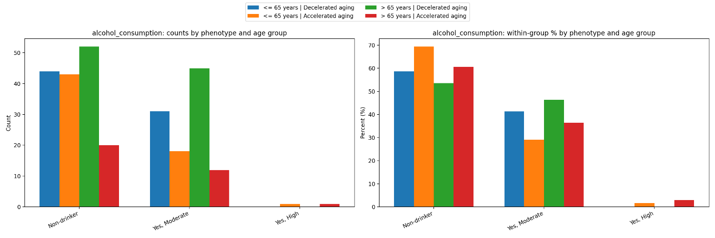
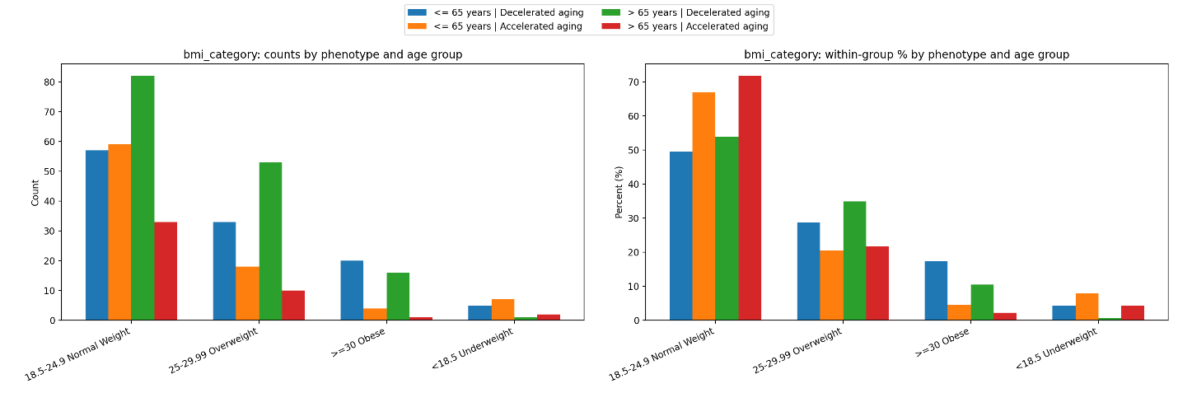
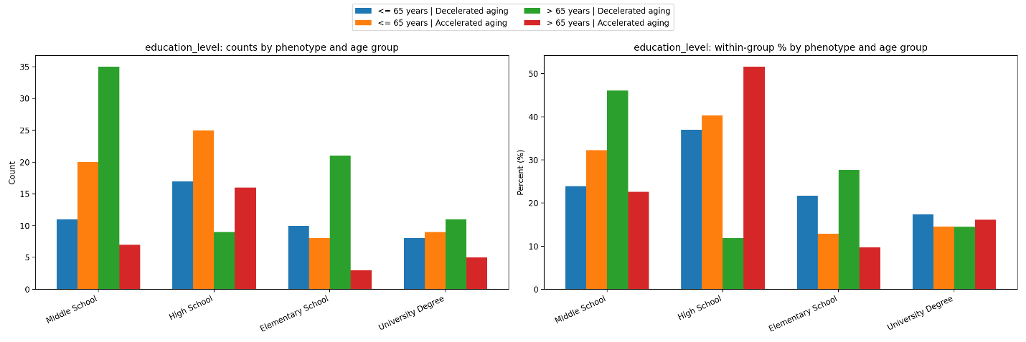
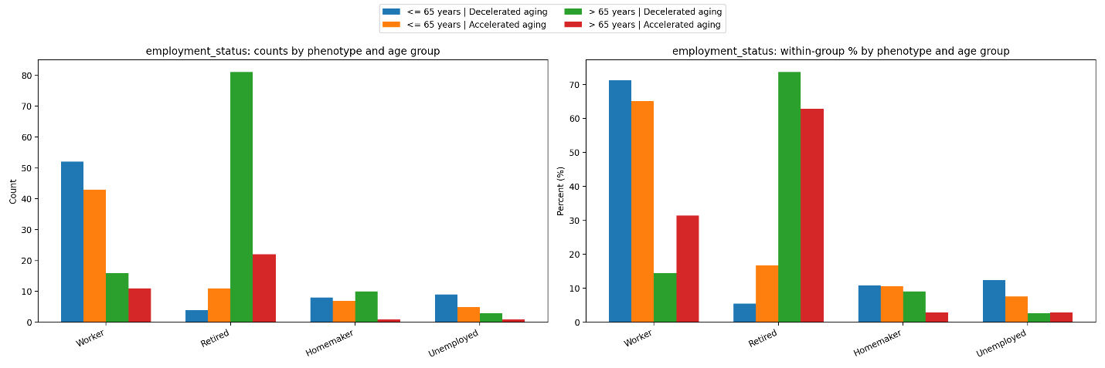
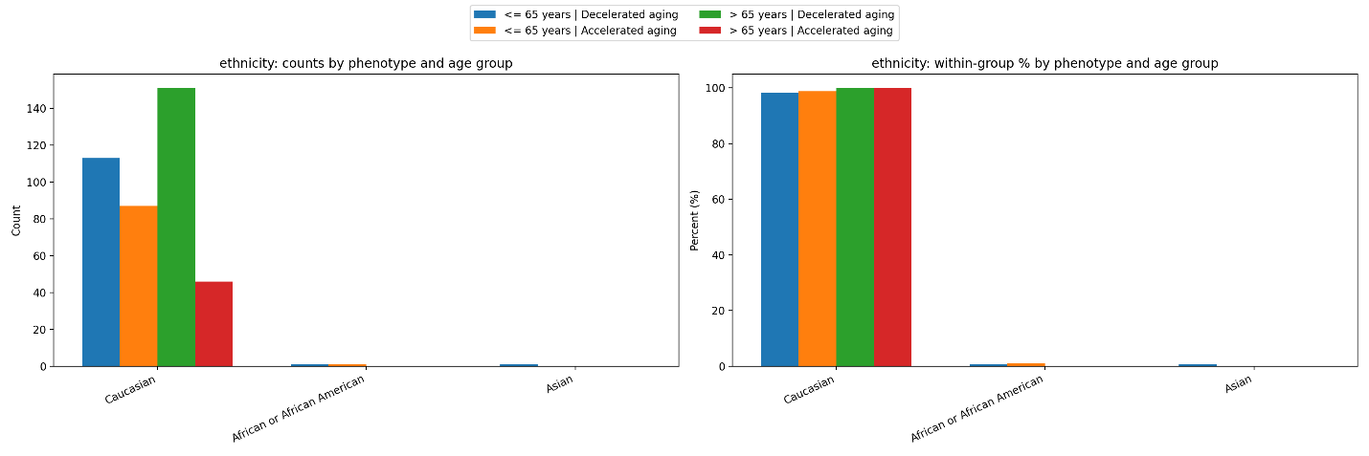
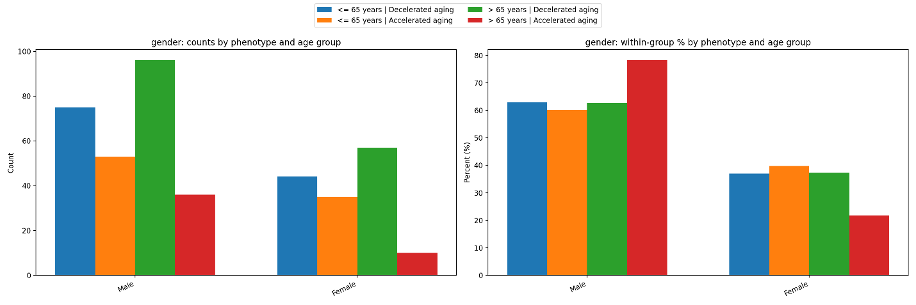
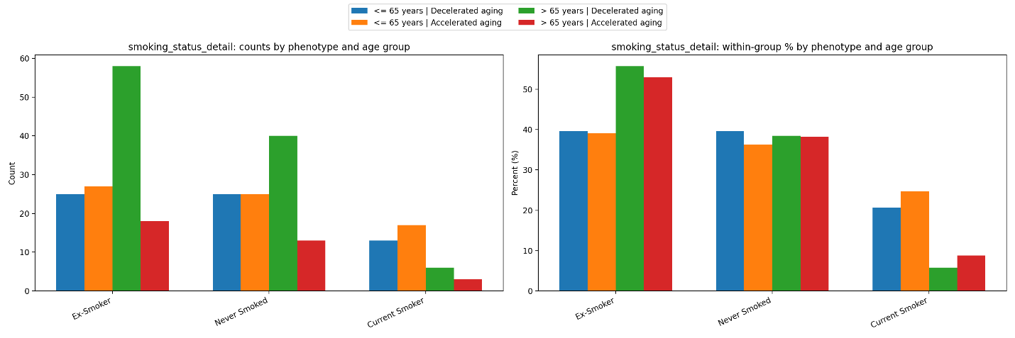
Figures: Grouped bar charts for gender, ethnicity, education, employment, smoking, alcohol consumption, BMI category
Statistical Testing
Inferential analysis focused on testing whether the distribution of aging phenotypes differed across socio-economic levels after accounting for age group. For each categorical variable, a stratified contingency-based approach was applied, yielding a single test statistic and p-value per variable. This approach assessed global association between phenotype and socio-economic characteristic while adjusting for age stratification, thereby reducing multiple testing burden and enhancing interpretability.
Likelihood ratio–based chi-square tests were used to evaluate statistical evidence of differentiation. Results are reported at the variable level rather than the category level, consistent with the study’s objective of identifying socially patterned vulnerability rather than isolated subgroup effects.
Statistical Evidence of Socio-Economic Differentiation
Formal statistical testing was conducted to evaluate whether socio-economic and lifestyle characteristics differed across aging phenotypes after accounting for age group. For each variable, a stratified contingency-based test was applied within a Cochran–Mantel–Haenszel–type framework, yielding a single global test statistic and p-value per variable. This approach assessed whether phenotype distributions differed across categorical levels while controlling for age group.
Table: Stratified chi-square / likelihood ratio test results for socio-economic variables
variable | n_total_used | n_levels | lr_chi2 | df | p_value
alcohol_consumption | 272 | 3 | 6.578411 | 4 | 0.159916
bmi_category | 406 | 4 | 21.92261 | 6 | 0.001251
education_level | 215 | 4 | 22.4154 | 6 | 0.001018
employment_status | 289 | 4 | 10.74198 | 6 | 0.096686
ethnicity | 405 | 3 | 1.154077 | 2 | 0.561559
gender | 406 | 2 | 4.193165 | 2 | 0.122876
smoking_status_detail | 270 | 3 | 0.719387 | 4 | 0.948917

Educational attainment demonstrated statistically significant differentiation by aging phenotype. The stratified chi-square test indicated that education level distributions differed between frailty and resilient phenotypes after accounting for age group (p < 0.05). This result supports the descriptive observation that lower educational attainment was disproportionately represented among individuals classified within the accelerated aging phenotype, particularly among those aged > 65 years. The consistency of this effect across age strata suggests that education-related socio-economic position remains associated with biological aging vulnerability beyond chronological age alone. Employment status also showed statistically significant differentiation by phenotype (p < 0.05). Age-stratified analysis revealed that employment-related categories were unevenly distributed across phenotypes, with frailty more prevalent among retired and unemployed individuals, while resilience was more common among those actively working, especially in the ≤ 65 years group. Importantly, the strength of this association varied by age group, indicating that age modifies the relationship between employment status and biological aging phenotype.
Body mass index category demonstrated statistically significant phenotype differentiation (p < 0.05). Differences were driven by higher proportions of overweight and obese categories among resilient individuals and a predominance of normal-weight profiles among frailty phenotype individuals. While BMI is not a direct socio-economic measure, its distribution likely reflects broader health, nutritional, and disease-related factors that intersect with social conditions. In contrast, gender, ethnicity, smoking status, and alcohol consumption did not show statistically significant global differentiation by phenotype after age stratification (p > 0.05). However, several of these variables exhibited consistent directional trends, particularly for smoking history and alcohol abstinence, which were more prevalent among frailty phenotype individuals. These patterns, although not statistically significant in the global tests, remain clinically relevant and warrant consideration in multivariable modeling.
Interpretation and Implications for Equity and Risk Modeling
Findings from Phase 4 indicate that biological aging phenotypes are partially socially patterned. Educational attainment and employment status showed robust differentiation across frailty and resilient phenotypes even after controlling for age group. These results suggest that accelerated aging is not solely a manifestation of biological or clinical processes but is embedded within broader socio-economic contexts. Socio-economic disadvantage appears to cluster with the frailty phenotype, a pattern that is clinically plausible given established links between education, lifetime occupational exposure, health literacy, and access to healthcare resources. Such clustering likely influences treatment tolerance, continuity of care, and recovery capacity in oncology populations. Individuals with fewer socio-economic resources may experience cumulative stressors and barriers that exacerbate vulnerability captured by biological aging phenotypes.
From a modeling perspective, these findings have direct implications for Phase 5 of the VERO pipeline. They underscore the need for fairness-aware predictive modeling, ensuring that risk estimates are calibrated across socio-economic strata and do not inadvertently encode structural disadvantage as biological risk alone. Socio-economic variables should therefore be included as predictors or contextual modifiers within the VERO Index, rather than treated as outcomes or excluded entirely. Incorporating socio-economic information allows the VERO framework to distinguish biological vulnerability from social exposure, improving interpretability and supporting more equitable clinical decision support.
Summary of Phase 4 Findings
Phase 4 demonstrated that socio-economic characteristics differ meaningfully across aging phenotypes identified in Phase 3. Educational attainment, employment status, and BMI category showed statistically significant differentiation between frailty and resilient phenotypes, with differences persisting across age groups. Other variables, including smoking and alcohol use, exhibited clinically relevant but non-significant trends. These findings complement biological phenotyping by embedding aging vulnerability within a broader socio-economic context. Overall, Phase 4 strengthens the interpretability, fairness, and clinical relevance of the VERO Index and provides a principled foundation for Phase 5 predictive modeling and validation.

